**Wi – Fi Control Robot Car Using Node MCU**

**SYNOPSIS ON MINOR PROJECT**

**Submitted for the partial fulfillment of Diploma in**

**Computer Engineering**



**Under the Supervision of**

**Dr. Puneet Sood**

**Submitted To:                                                                          Submitted By:**

Dept. of Computer Engineering                                                    Shivam Verma (170610404054)

                                                                                                  Tulsi Devi (170610404062)

Simran Kaur (170610404057)

**Abstract**

The main objective of this project is to develop a home automation system using an Arduino board with Bluetooth being remotely controlled by any Android OS smart phone. As technology is advancing so houses are also getting smarter. Modern houses are gradually shifting from conventional switches to centralized control system, involving remote controlled switches. Presently, conventional wall switches located in different parts of the house makes it difficult for the user to go near them to operate. Even more it becomes more difficult for the elderly or physically handicapped people to do so. Remote controlled home automation system provides a most modern solution with smart phones.

In order to achieve this, a Bluetooth module is interfaced to the Arduino board at the receiver end while on the transmitter end, a GUI application on the cell phone sends ON/OFF commands to the receiver where loads are connected. By touching the specified location on the GUI, the loads can be turned ON/OFF remotely through this technology. The loads are operated by Arduino board through opto- isolators and thyristors using triacs

**ACKNOWLEDGEMENT**

Keep away from people who try to belittle your ambitions. Small people always do that,

but the really great make you feel that you too, can become great.

We take this opportunity to express my sincere thanks and deep gratitude to all those

people who extended their wholehearted co-operation and have helped me in

completing this project successfully.

First of all, we would like to thank Dr.Puneet Sood (HOD) for creating opportunities for us to enhance our skill through the project. His inspiring suggestions and timely guidance enabled me to perceive the various aspects of the project. in a new light.

THANK YOU

**Contents**

ABSTRACT ............................................................................................................ 1

ACKNOWLEDGEMENT............................................................................................2

INTRODUCTION ..................................................................................................... 4

PROJECT AIM & SCOPE...........................................................................................5

DESCRIPTION OF PROJECT.....................................................................................6

H/W & S/W REQUIREMENT......................................................................................7

DESCRIPTION OF H/W REQUIRED............................................................................8

INTERFACING OF HC-05 MODULE...........................................................................11

DESIGN & IMPLEMENTATION..........................................................................................13

PROS & CONS..............................................................................................................16

APPLICATION..............................................................................................................18

FUTURE DEVELOPMENT................................................................................................18

CONCLUSION..................................................................................................................19

REFERENCE.....................................................................................................................20

**HARDWARE REQUIREMENTS**

* NodeMCU ESP8266-12E
* DC Motors
* Chassis
* Micro USB Cable (For NodeMCU)
* Jumper Wires (M to M, F to M, F to F)
* Mini Bread Board
* SG90 Micro Servo Motor
* Motor Driver L293D
* 9 Volt Battery

**SOFTWARE REQUIREMENTS**

* Arduino IDE
* Android Application
* Android Device

## Hardware Requirements

## NodeMCU ESP8266-12E

**NodeMCU** is an open source IoT platform It includes [firmware](https://en.wikipedia.org/wiki/Firmware) which runs on the [ESP8266](https://en.wikipedia.org/wiki/ESP8266) [Wi-Fi](https://en.wikipedia.org/wiki/Wi-Fi) [SoC](https://en.wikipedia.org/wiki/System_on_a_chip) from Espressif Systems, and hardware which is based on the ESP-12 module. The term "NodeMCU" by default refers to the firmware rather than the development kits. The firmware uses the [Lua](https://en.wikipedia.org/wiki/Lua_(programming_language))scripting language. It is based on the eLua project, and built on the Espressif Non-OS SDK for ESP8266. It uses many open source projects, such as lua-cjson and [SPIFFS](https://en.wikipedia.org/w/index.php?title=SPIFFS&action=edit&redlink=1).



History[[edit](https://en.wikipedia.org/w/index.php?title=NodeMCU&action=edit&section=1" \o "Edit section: History)]

NodeMCU was created shortly after the [ESP8266](https://en.wikipedia.org/wiki/ESP8266) came out. On December 30, 2013, [Espressif Systems](https://en.wikipedia.org/w/index.php?title=Espressif_Systems&action=edit&redlink=1)[[6]](https://en.wikipedia.org/wiki/NodeMCU#cite_note-Espressif_Systems-6) began production of the ESP8266.[[10]](https://en.wikipedia.org/wiki/NodeMCU#cite_note-10) The ESP8266 is a Wi-Fi SoC integrated with a [Tensilica](https://en.wikipedia.org/wiki/Tensilica" \o "Tensilica) Xtensa LX106 core,[*[citation needed](https://en.wikipedia.org/wiki/Wikipedia:Citation_needed" \o "Wikipedia:Citation needed)*] widely used in IoT applications (see [related projects](https://en.wikipedia.org/wiki/NodeMCU#Related_projects)). NodeMCU started on 13 Oct 2014, when Hong committed the first file of nodemcu-firmware to GitHub.[[11]](https://en.wikipedia.org/wiki/NodeMCU#cite_note-11) Two months later, the project expanded to include an open-hardware platform when developer Huang R committed the [gerber](https://en.wikipedia.org/wiki/Gerber_format" \o "Gerber format) file of an ESP8266 board, named devkit v0.9.[[12]](https://en.wikipedia.org/wiki/NodeMCU#cite_note-init_devkit-12) Later that month, Tuan PM ported [MQTT](https://en.wikipedia.org/wiki/MQTT) client library from [Contiki](https://en.wikipedia.org/wiki/Contiki" \o "Contiki) to the ESP8266 SoC platform,[[13]](https://en.wikipedia.org/wiki/NodeMCU" \l "cite_note-mqtt_client-13) and committed to NodeMCU project, then NodeMCU was able to support the MQTT IoT protocol, using Lua to access the MQTT broker. Another important update was made on 30 Jan 2015, when Devsaurus ported the u8glib[[14]](https://en.wikipedia.org/wiki/NodeMCU" \l "cite_note-u8g-14) to NodeMCU project,[[15]](https://en.wikipedia.org/wiki/NodeMCU#cite_note-u8glib-15) enabling NodeMCU to easily drive LCD, Screen, OLED, even VGA displays.

In summer 2015 the creators abandoned the firmware project and a group of independent contributors took over. By summer 2016 the NodeMCU included more than 40 different modules. Due to resource constraints users need to select the modules relevant for their project and build a firmware tailored to their needs.

Related projects

1. ESP8266 Board

2. L293D IC or L298 Motor driver board

3. Robot Chassis with Motors (I used 500 rpm motors)

4. Breadboard or PCB (If you prefer to solder)

5. 6v AA Battery Pack or a 9v Battery (To power the ESP8266)

5. A battery (To power the motors)[Which one to choose in step 3]

Add TipAsk QuestionCommentDownload

## Step 2: ESP8266 Board - Which One to Pick ?

[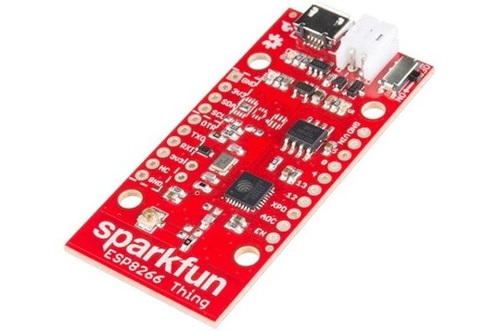](https://cdn.instructables.com/FZ9/500E/JBMK3FNP/FZ9500EJBMK3FNP.LARGE.jpg?auto=webp&fit=bounds)

5. 6v AA Battery Pack or a 9v Battery (To power the ESP8266)

5. A battery (To power the motors)[Which one to choose in step 3]

[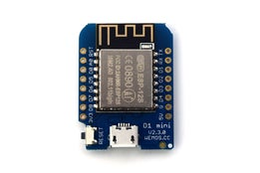](https://cdn.instructables.com/FLV/459N/JBMK3FMZ/FLV459NJBMK3FMZ.LARGE.jpg?auto=webp&width=1024&fit=bounds)

1. Adafruit Feather Huzzah - It is made by adafruit thus it has easily available instructions and support. It doesn't come with soldered header pins so you will need a soldering iron to solder them. It has li-po battery charger on the board itself, so it will come really handy in portable projects. It costs $16

2. NodeMCU ESP8266 - It is just the basic board with no extra features but it is open source and has excellent documentation so it will be very easy to get started. But the best part is that you can buy it for less than $4.

3. Sparkfun ESP8266 - It is like the huzzah with the addition of a power switch and an external antenna for a longer Wifi range and it also costs $16

4. Wemos D1 Mini - It is the smallest of all the boards but this doesn't have any effect on the performance. It has nice documentation and it only costs $4. If you want a longer range and the same form factor then you could buy the Wemos D1 Mini Pro which has a external antenna

Finally, the one I would recommend is the NodeMCU ESP8266 because it has excellent documentation and how cheap it is. If you are building a portable project then I would recommend the sparkfun board because of the external antenna and the built-in li-po charger and sparkfun makes good quality products.

Add TipAsk QuestionCommentDownload

## Step 3: Battery - Which One to Choose ?

[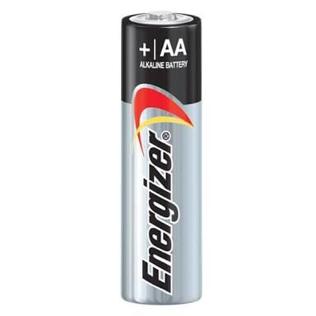](https://cdn.instructables.com/FTC/GBU9/JBQUNT6U/FTCGBU9JBQUNT6U.LARGE.jpg?auto=webp&fit=bounds)

[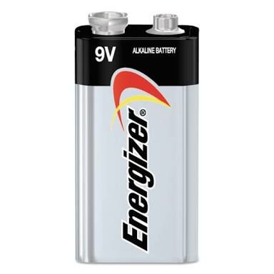](https://cdn.instructables.com/F9U/AP2Y/JBQUNT6P/F9UAP2YJBQUNT6P.LARGE.jpg?auto=webp&fit=bounds)

[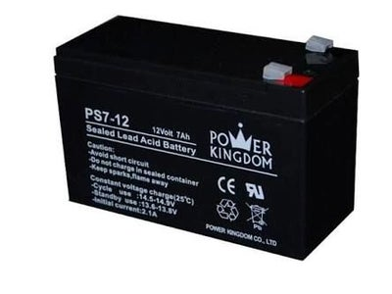](https://cdn.instructables.com/FRA/Z700/JBQUNT6Q/FRAZ700JBQUNT6Q.LARGE.jpg?auto=webp&fit=bounds)

2 More Images

There are many different kinds of batteries to choose from, you have to select the right one for you.

1. AA Battery Pack - They are the most common type of batteries and are very cheap. Each cell has a voltage of 1.5 volts, we need at least 9 volts, so we would need to wire 6 - 8 cells in series to get 9 -12 volts.

2. 9v Battery - This is also a very common type of battery and also cheap. It has a voltage of 9 volts but the maximum current and capacity is pretty low, so it wouldn't last long and the motors will spin quite slow.

3. Lead Acid Battery - It is also pretty common as it is used every car out there. It has a voltage of 12 volts, it has the perfect voltage for our needs. It's current capability is good and has a large capacity. The only part where it isn't good is the size and weight, it is big and heavy.

4. Li-Ion (Lithium Ion) - It is the type of battery that is used in power banks. It comes in different sizes but the most popular is the 18650 cell. The maximum voltage is 4.2 volts and minimum is 3.7 volts. If you charge or discharge it more than those parameters then the battery would be damaged. A special type of charger is needed to charge these batteries. It has a high current capability and a large capacity and is also very small, only a little bigger than AA battery. But it doesn't come as pre-built battery packs, so you would have to buy individual cells and create a battery pack.

5. Li-Po (Lithium Polymer) - It is mostly used in quadcopters and drones and in hobby rc vehicles. The maximum and minimum voltage is same as an Li-Ion battery. A special charger is also needed to charge them. It has the highest current capability out of all these and also has a large capacity and is also small. But is dangerous, if you don't handle them properly they could catch on fire.

For beginners I would recommend a AA battery pack or a Lead acid battery and for advanced users a Li-Po battery. If you want to learn more about comparison between different types of batteries then watch this [video made by Great Scott](https://www.youtube.com/watch?v=LqgP16JQ24I).

Add TipAsk QuestionCommentDownload

## Step 4: Assembling the Chassis

[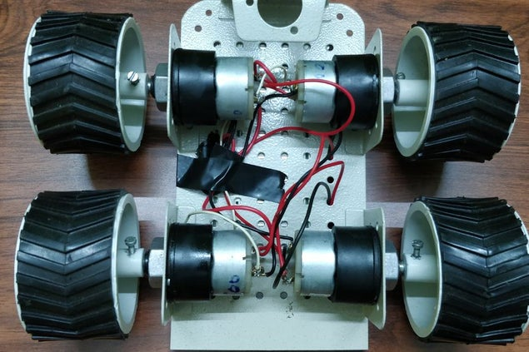](https://cdn.instructables.com/FLV/QUOH/JBWJX7NO/FLVQUOHJBWJX7NO.LARGE.jpg?auto=webp&width=1024&height=1024&fit=bounds)

[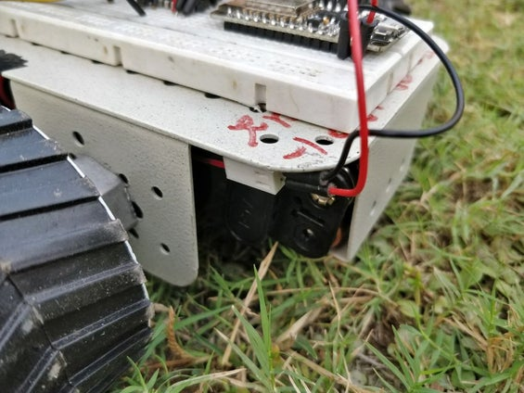](https://cdn.instructables.com/F37/S1N2/JBWK0ADG/F37S1N2JBWK0ADG.LARGE.jpg?auto=webp&width=1024&height=1024&fit=bounds)

I used 4 motors to make it a 4 wheel drive but you can make it a 2 wheel drive by removing the front two motors and replace them with dummy wheels or add a castor wheel. To assemble the chassis solder wires onto the motors and mount the motors on the chassis. If you don't have a soldering iron then you can twist the wires and attach them with electrical tape but it is not recommended as it will be quite a weak joint. I have mounted the 6v AA battery pack where the castor wheel is supposed to be attached The assembly will be different for every different chassis but is a very easy process.

Add TipAsk QuestionCommentDownload

## Step 5: Adding ESP8266 in Arduino IDE

[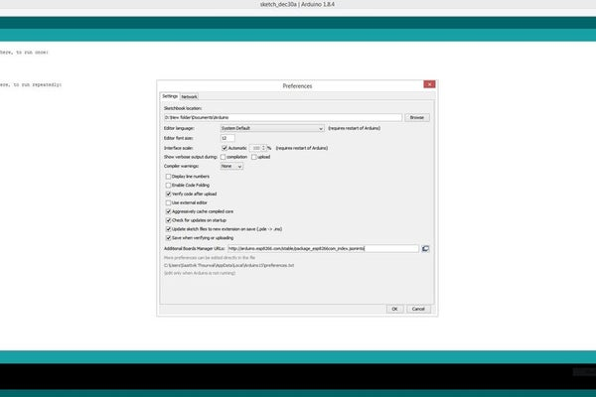](https://cdn.instructables.com/FPQ/BNEQ/JBQUACY1/FPQBNEQJBQUACY1.LARGE.jpg?auto=webp&width=1024&height=1024&fit=bounds)

[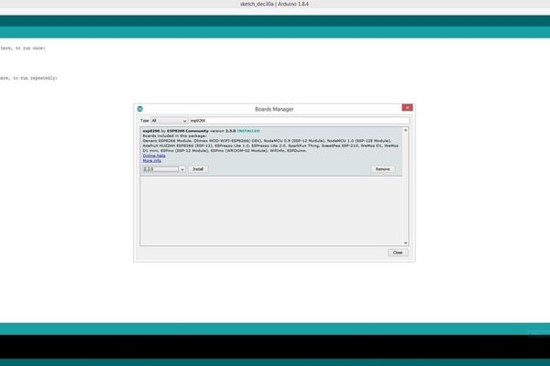](https://cdn.instructables.com/FJW/65GL/JBQUACXN/FJW65GLJBQUACXN.LARGE.jpg?auto=webp&width=1024&height=1024&fit=bounds)

The esp8266 boards don't come installed in the arduino IDE. To install follow these instructions -

1. Start Arduino and open Preferences window

2. Enter "http://arduino.esp8266.com/stable/package\_esp8266com\_index.jsoninto" into Additional Board Manager URLs field

3. Open Boards Manager from Tools > Board menu and find esp8266 platform

4. Select the latest version from a drop-down box and click the install button

5. Don't forget to select your ESP8266 board from Tools > Board menu after installation

Add TipAsk QuestionCommentDownload

## Step 6: Finding the IP Address of the ESP8266

[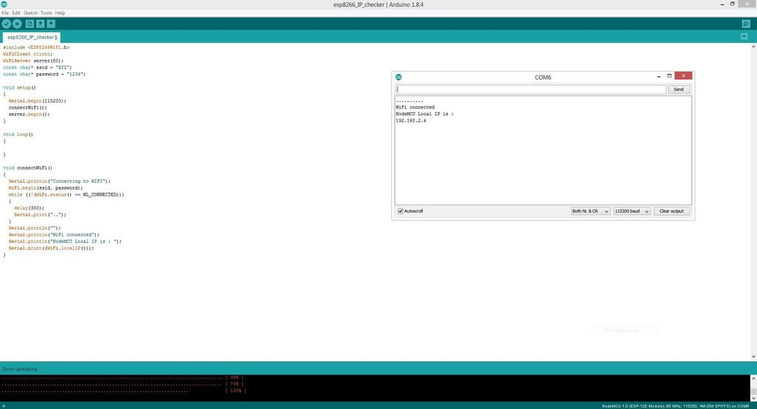](https://cdn.instructables.com/FBV/S8BL/JBQUHXU4/FBVS8BLJBQUHXU4.LARGE.jpg?auto=webp&width=1024&height=1024&fit=bounds)

1. Open the give code in the Arduino IDE

2. Find where it says "YOUR SSID" and erase it and write your wifi's SSID (Between the inverted commas) which is the name of your wifi network.

2. Below it, it will say "YOUR PASSWORD" erase it and write the password of your wifi network (Between the inverted commas)

3. After you have made the changes upload the code to your ESP8266 Board

4. Unplug the board from your computer and plug it again

5. Open the serial monitor and set the baud rate to 115200 and choose "Both NL and CR". It will say "wifi connected" and will also show the IP address. Note down the IP address because we will need it later.

#### Attachments

* [esp8266_IP_checker.ino**esp8266\_IP\_checker.ino**](https://cdn.instructables.com/ORIG/F3Q/JYC0/JBQU5N3O/F3QJYC0JBQU5N3O.ino)

[Download](https://cdn.instructables.com/ORIG/F3Q/JYC0/JBQU5N3O/F3QJYC0JBQU5N3O.ino)

Add TipAsk QuestionCommentDownload

## Step 7: Circuit

[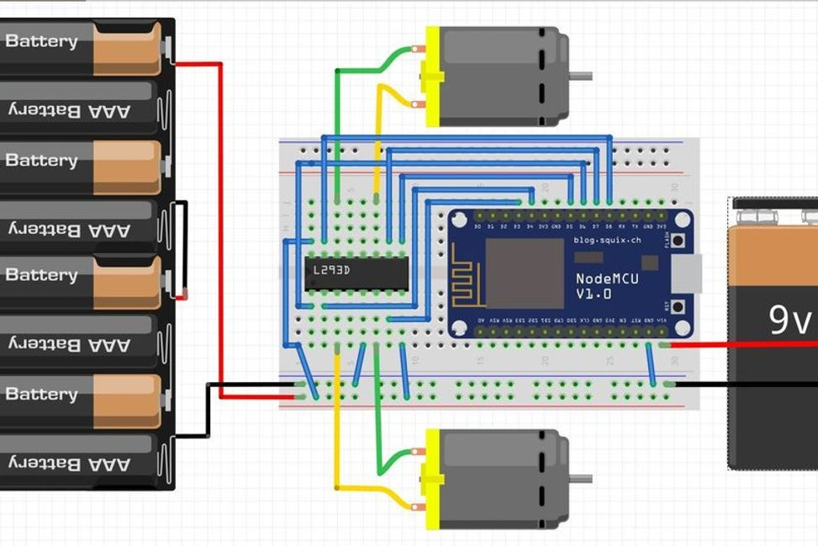](https://cdn.instructables.com/F9Q/N602/JBWK0EI6/F9QN602JBWK0EI6.LARGE.jpg?auto=webp&width=1024&fit=bounds)

[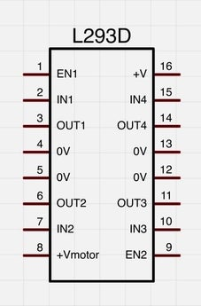](https://cdn.instructables.com/F04/JXDQ/JBQUAB30/F04JXDQJBQUAB30.LARGE.jpg?auto=webp&fit=bounds)

[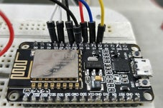](https://cdn.instructables.com/FMT/ES1B/JBQUHGO3/FMTES1BJBQUHGO3.LARGE.jpg?auto=webp&width=1024&height=1024&fit=bounds)

[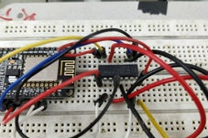](https://cdn.instructables.com/FZN/2B3H/JBQUHJYC/FZN2B3HJBQUHJYC.LARGE.jpg?auto=webp&width=1024&height=1024&fit=bounds)

The circuit is very simple. Instead of the AA battery pack you can use any other type of battery.

NodeMCU - L293D

D3 - Pin 7

D4 - Pin 2

D5 - Pin 9

D6 - Pin 1

D7 - Pin 10

D8 - Pin 15

Gnd - Battery Negative

Both the AA battery pack and 9v battery should have a common ground connection.

Add TipAsk QuestionCommentDownload

## Step 8: Programming

[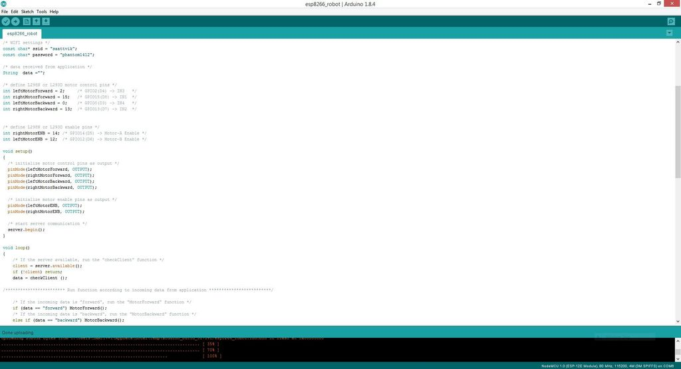](https://cdn.instructables.com/F6H/QTOW/JBQUHFW4/F6HQTOWJBQUHFW4.LARGE.jpg?auto=webp&width=1024&height=1024&fit=bounds)

Open the given code in the arduino IDE and write you wifi network's SSID and password like I shown you before then upload the code to your ESP8266 Board.

#### Attachments

* [esp8266_robot.ino**esp8266\_robot.ino**](https://cdn.instructables.com/ORIG/FT9/VZFB/JBQU5N3P/FT9VZFBJBQU5N3P.ino)

[Download](https://cdn.instructables.com/ORIG/FT9/VZFB/JBQU5N3P/FT9VZFBJBQU5N3P.ino)

Add TipAsk QuestionCommentDownload

## Step 9: Installing the Control App

[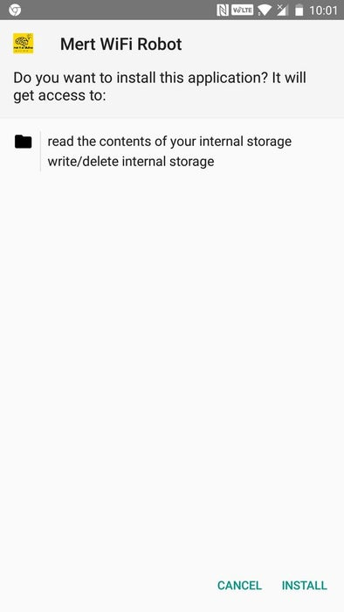](https://cdn.instructables.com/F0S/31DM/JBQUHUQ9/F0S31DMJBQUHUQ9.LARGE.jpg?auto=webp&width=1024&height=1024&fit=bounds)

This robot is controlled through an app, download the ESP8266\_robot.apk file and install it on your smartphone.

There is also the .aia file if you want to make any changes to the app.

#### Attachments

* [ESP8266_Robot.apk**ESP8266\_Robot.apk**](https://cdn.instructables.com/ORIG/FID/D9DD/JBQUADHA/FIDD9DDJBQUADHA.apk)

[Download](https://cdn.instructables.com/ORIG/FID/D9DD/JBQUADHA/FIDD9DDJBQUADHA.apk)

* [ESP8266_Robot_AIA.aia**ESP8266\_Robot\_AIA.aia**](https://cdn.instructables.com/ORIG/FBI/R0KX/JCAUITNS/FBIR0KXJCAUITNS.aia)

[Download](https://cdn.instructables.com/ORIG/FBI/R0KX/JCAUITNS/FBIR0KXJCAUITNS.aia)

Add TipAsk QuestionCommentDownload

## Step 10: Controlling the Robot

[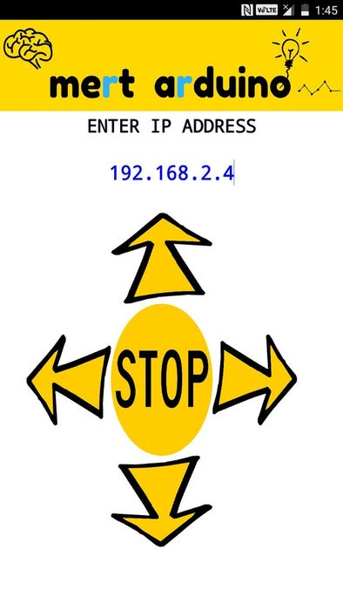](https://cdn.instructables.com/FDY/BS1O/JBQUFSMM/FDYBS1OJBQUFSMM.LARGE.jpg?auto=webp&width=1024&height=1024&fit=bounds)

Open the app and write the IP address of your ESP8266 Board and now you will be able to control it !!!

#Troubleshooting#

If the motors are spinning in the wrong direction then just interchange their connections to the L293D or interchange the control pins. The ESP8266 connects to wifi through DHCP, meaning that almost every time you connect it will have a different IP address, so you will need to check the IP address every time.

Add TipAsk QuestionCommentDownload

## Step 11: Some Pictures and Videos

[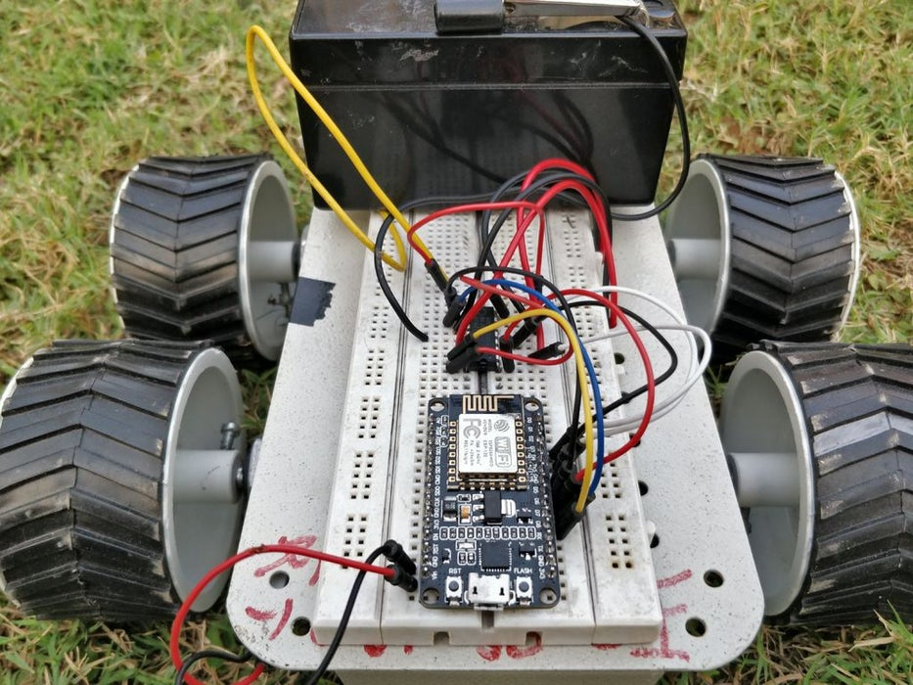](https://cdn.instructables.com/F5Z/KLV8/JBWK0AHK/F5ZKLV8JBWK0AHK.LARGE.jpg?auto=webp&width=1024&height=1024&fit=bounds)

It is very fast with a 12v battery, but if you think that it is too fast then you can lower the speed, first find the ENB pins in the code, you can write 0 to 250 instead of HIGH to set the speed. For example, "analogWrite (leftMotorENB, 170)